Rhetorical Grammar: Chapter 1

Answer Key

Exercise 1: Headwords and Determiners
Exercise 1a. CGI helped produce the lush, cinematic rain forests of James Cameron’s Avatar as well as the teeming orc armies of Peter Jackson’s Hobbit series.
Headwords: CGI • rain forests • Avatar • armies • series (also Cameron and Jackson inside possessive DPs)
Determiners: the (before “lush, cinematic rain forests”) • James Cameron’s (possessive Det for “Avatar”) • the (before “teeming orc armies”) • Peter Jackson’s (possessive Det for “Hobbit series”)
Exercise 1b. In the operating room, surgeons may rely on three-dimensional images to improve their patients’ prognoses.
Headwords: room • surgeons • images • prognoses
Determiners: the (before “operating room”) • their (Determiner for patients’) • patients’ (possessive Det for “prognoses”)
Exercise 1c. Clearly, this innovation has the potential to shape our future.
Headwords: innovation • potential • future
Determiners: this (before “innovation”) • the (before “potential”) • our (before “future”)

Exercise 2: Subject / Predicate
Exercise 2.1. The mayor’s husband / spoke against the ordinance.
Subject: The mayor’s husband
Predicate: spoke against the ordinance
Exercise 2.2. The merchants in town / are unhappy.
Subject: The merchants in town
Predicate: are unhappy
Exercise 2.3. The three white monkeys / carelessly climbed on their tall tree.
Subject: The three white monkeys
Predicate: carelessly climbed on their tall tree

Exercise 3: Prepositional Phrases
Exercise 3.1. Birthday cakes are common in many Western cultures.
PP: “in many Western cultures”
Function: Adverbial — modifies “are common,” indicating context/location (the exact attachment is somewhat ambiguous: it could modify “common,” “are,” or the whole clause)
Exercise 3.2. Cupcakes are a popular alternative to birthday cakes.
PP: “to birthday cakes”
Function: Adjectival — modifies the noun “alternative”
Tree diagram:
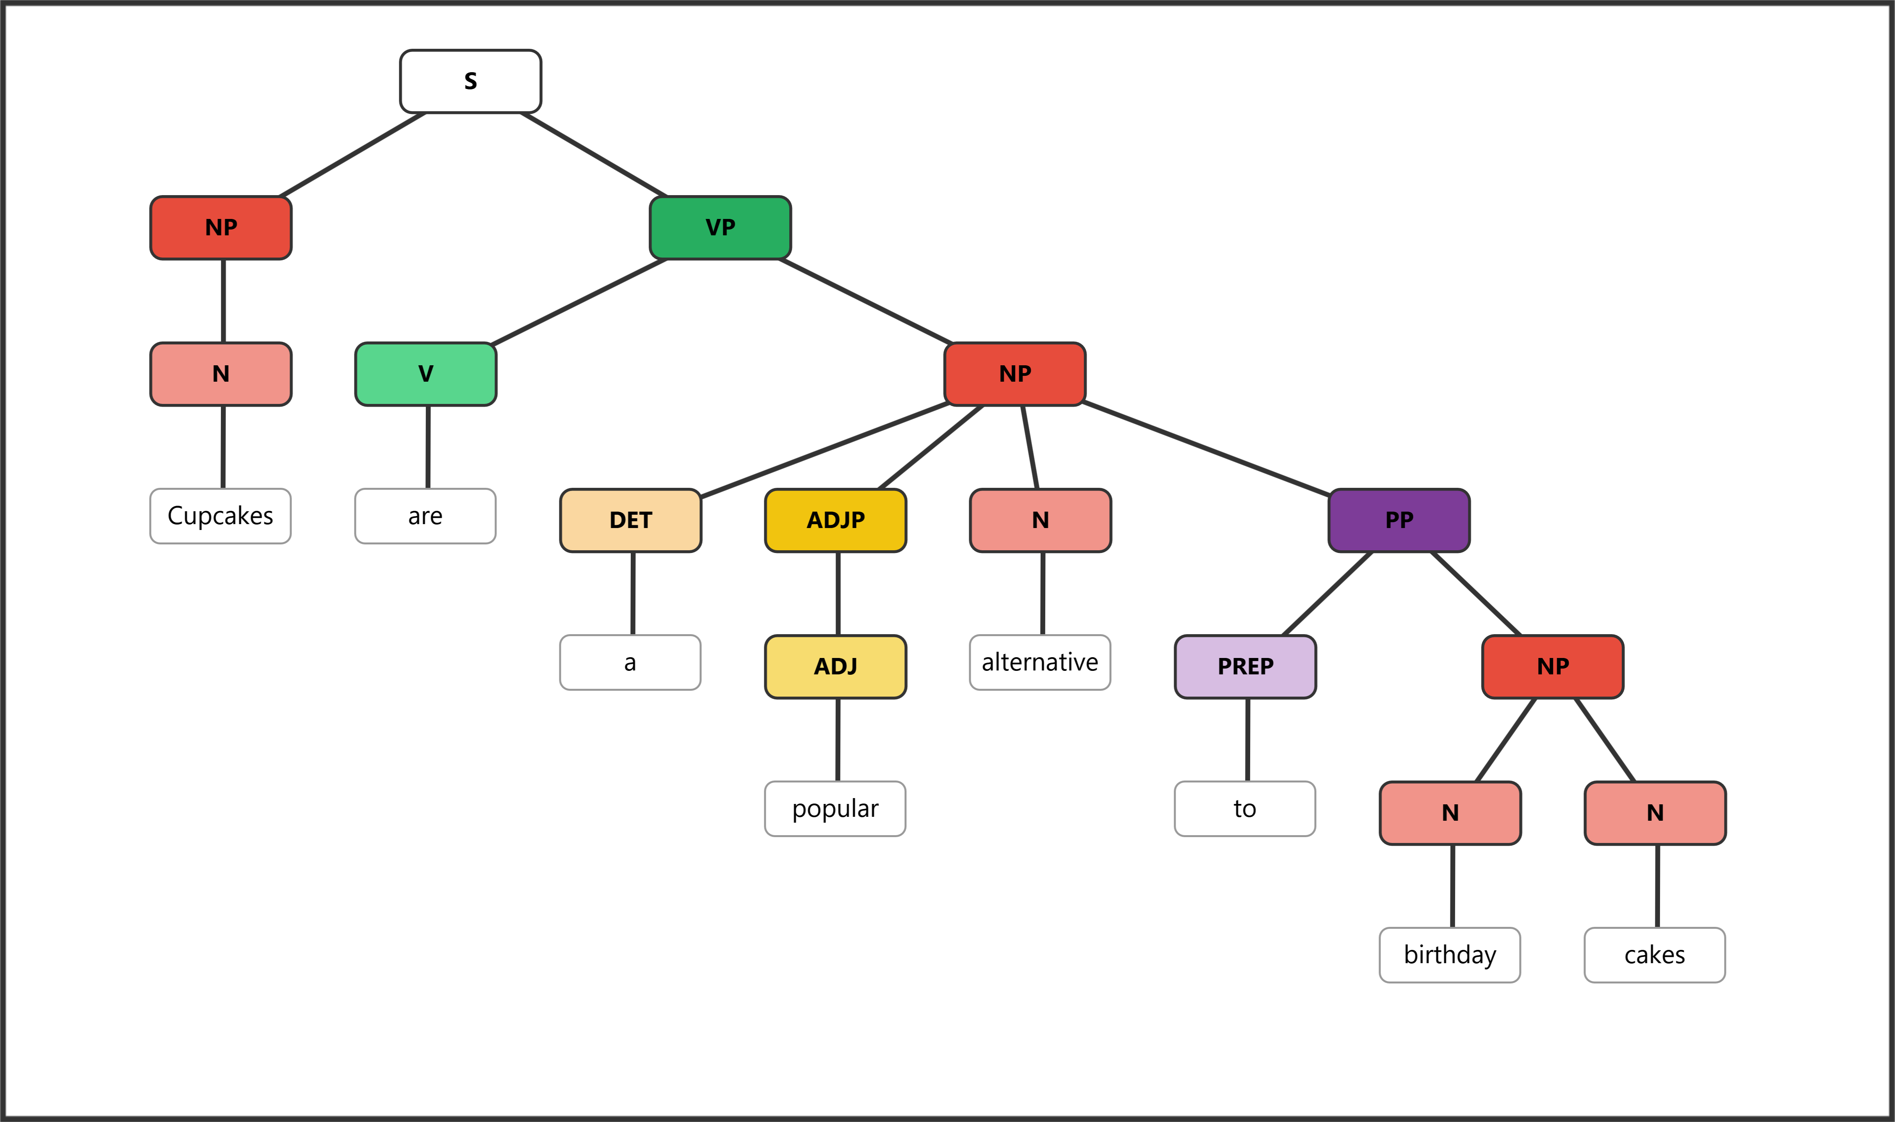
Exercise 3.3. The man in the big red hat spoke eloquently about his vacation to Morocco.
PP 1: “in the big red hat”
Function: Adjectival — modifies the noun “man”
PP 2: “about his vacation”
Function: Adverbial — modifies the verb “spoke”
PP 3: “to Morocco”
Function: Adjectival — modifies the noun “vacation”

Exercise 4: Sentence Labeling Tables
Note: Bracket notation and tree diagram are provided below each table. Student diagrams drawn in the diagramming app should match the tree structure.
Practice One: Bears seldomly attack without a very good reason.
Phrase | NP | VP | VP | PP | PP | PP | PP | PP
Word | Bears | seldomly | attack | without | a | very | good | reason
Part of Speech | N | Adv | V | Prep | Det | Adv | Adj | N

Bracket notation:
[NP Bears] [VP seldomly attack [PP without [NP a very good reason]]]
Tree diagram:
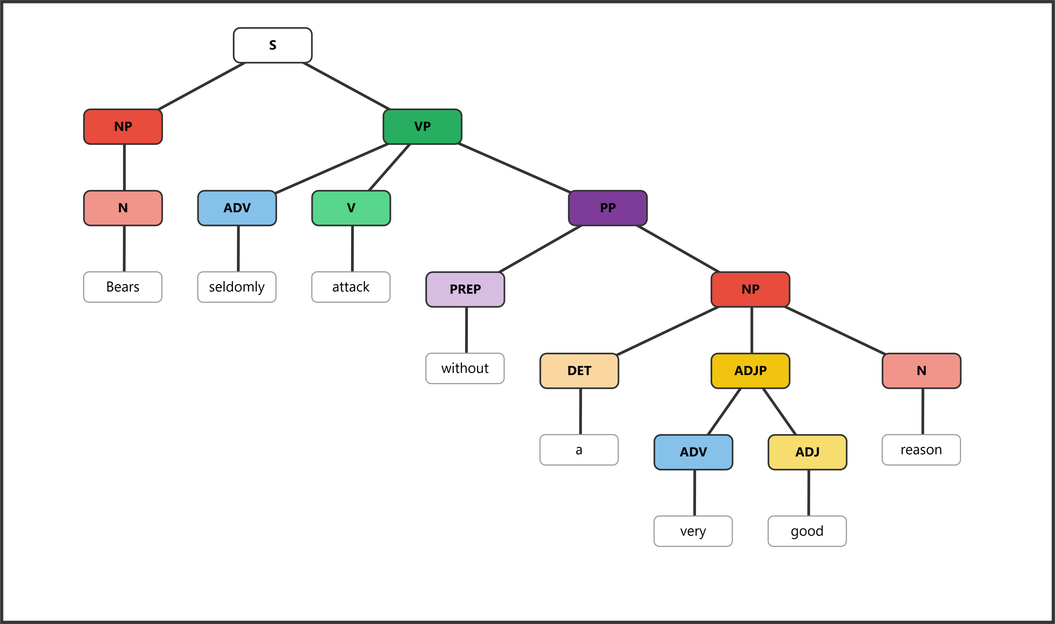
Practice Two: Stephen usually sits alone at home.
Phrase | NP | VP | VP | VP | PP | PP
Word | Stephen | usually | sits | alone | at | home
Part of Speech | N | Adv | V | Adv | Prep | N

Bracket notation:
[NP Stephen] [VP usually sits alone [PP at [NP home]]]
Tree diagram:
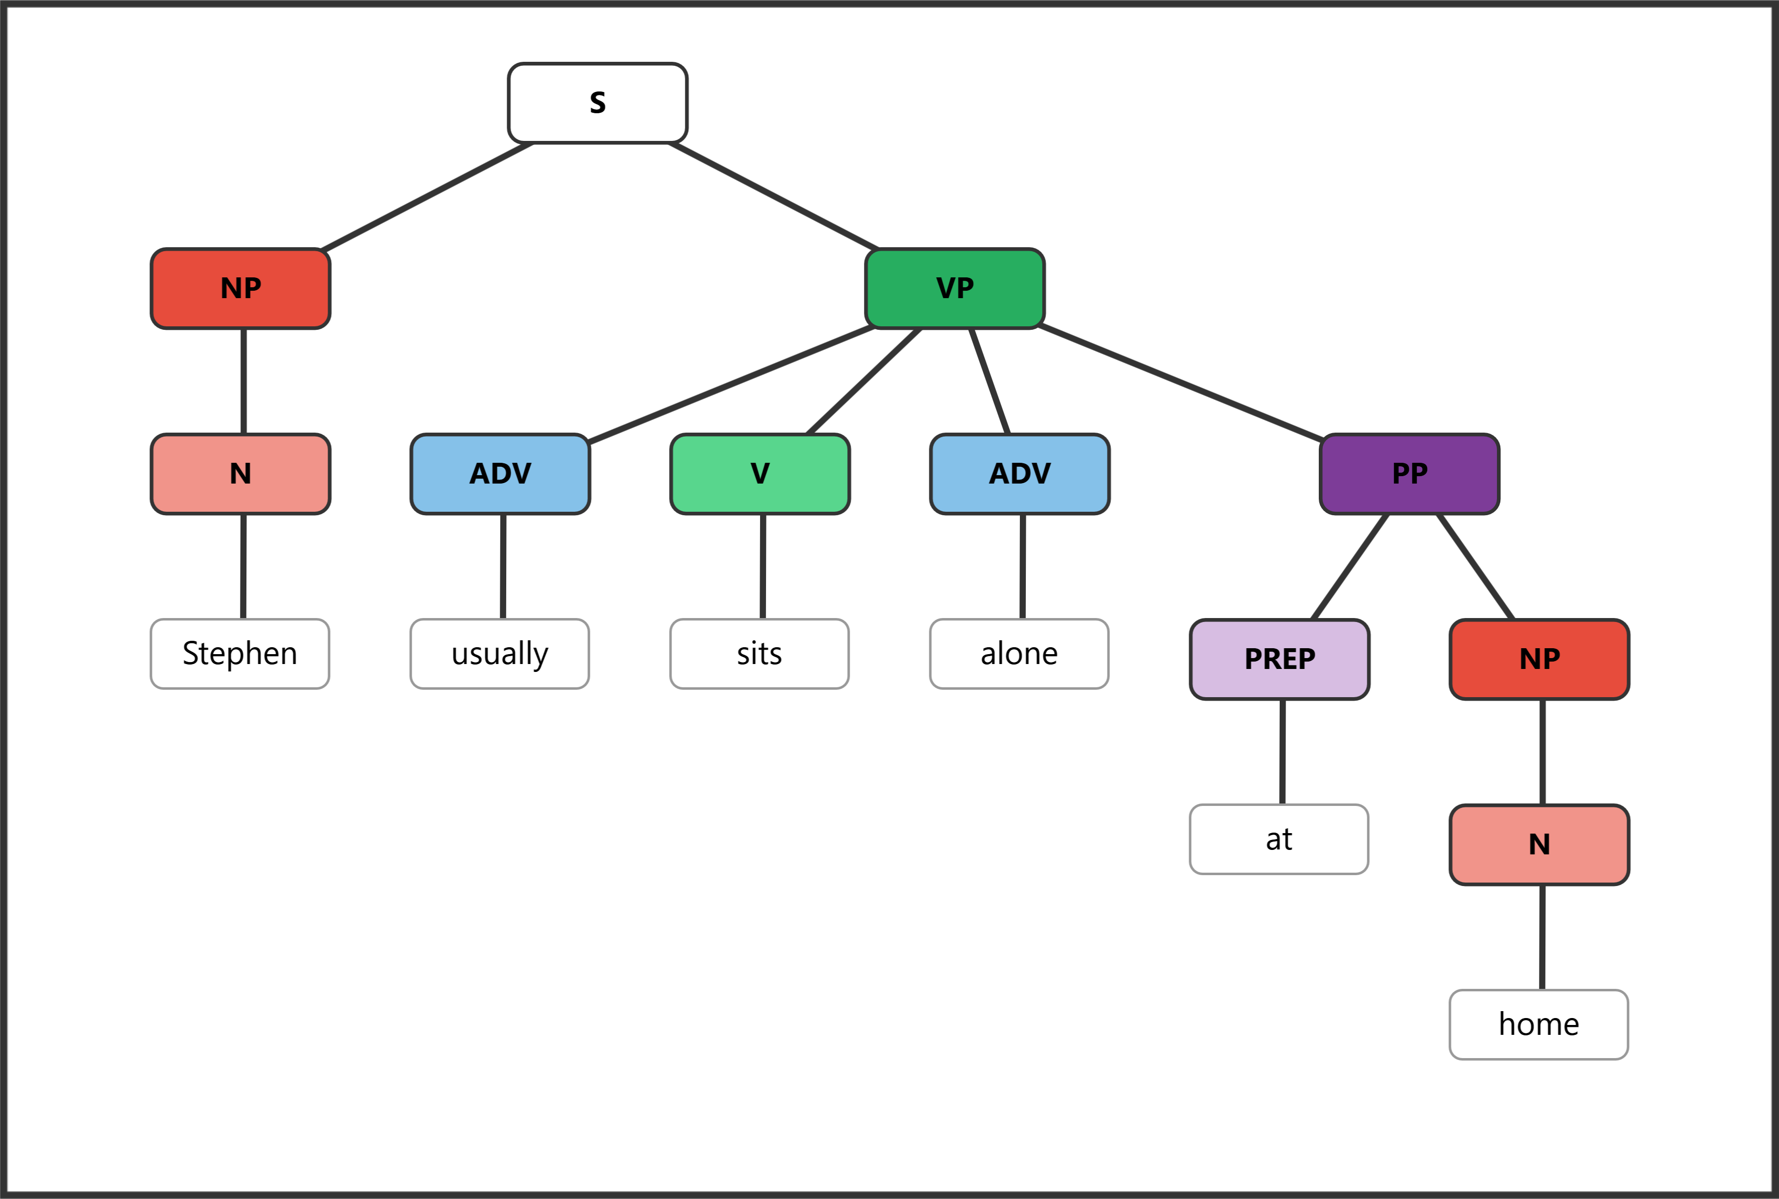
Practice Three: My younger brother works for the city.
Phrase | NP | NP | NP | VP | PP | PP | PP
Word | My | younger | brother | works | for | the | city
Part of Speech | Det | Adj | N | V | Prep | Det | N

Bracket notation:
[NP My younger brother] [VP works [PP for [NP the city]]]
Tree diagram:
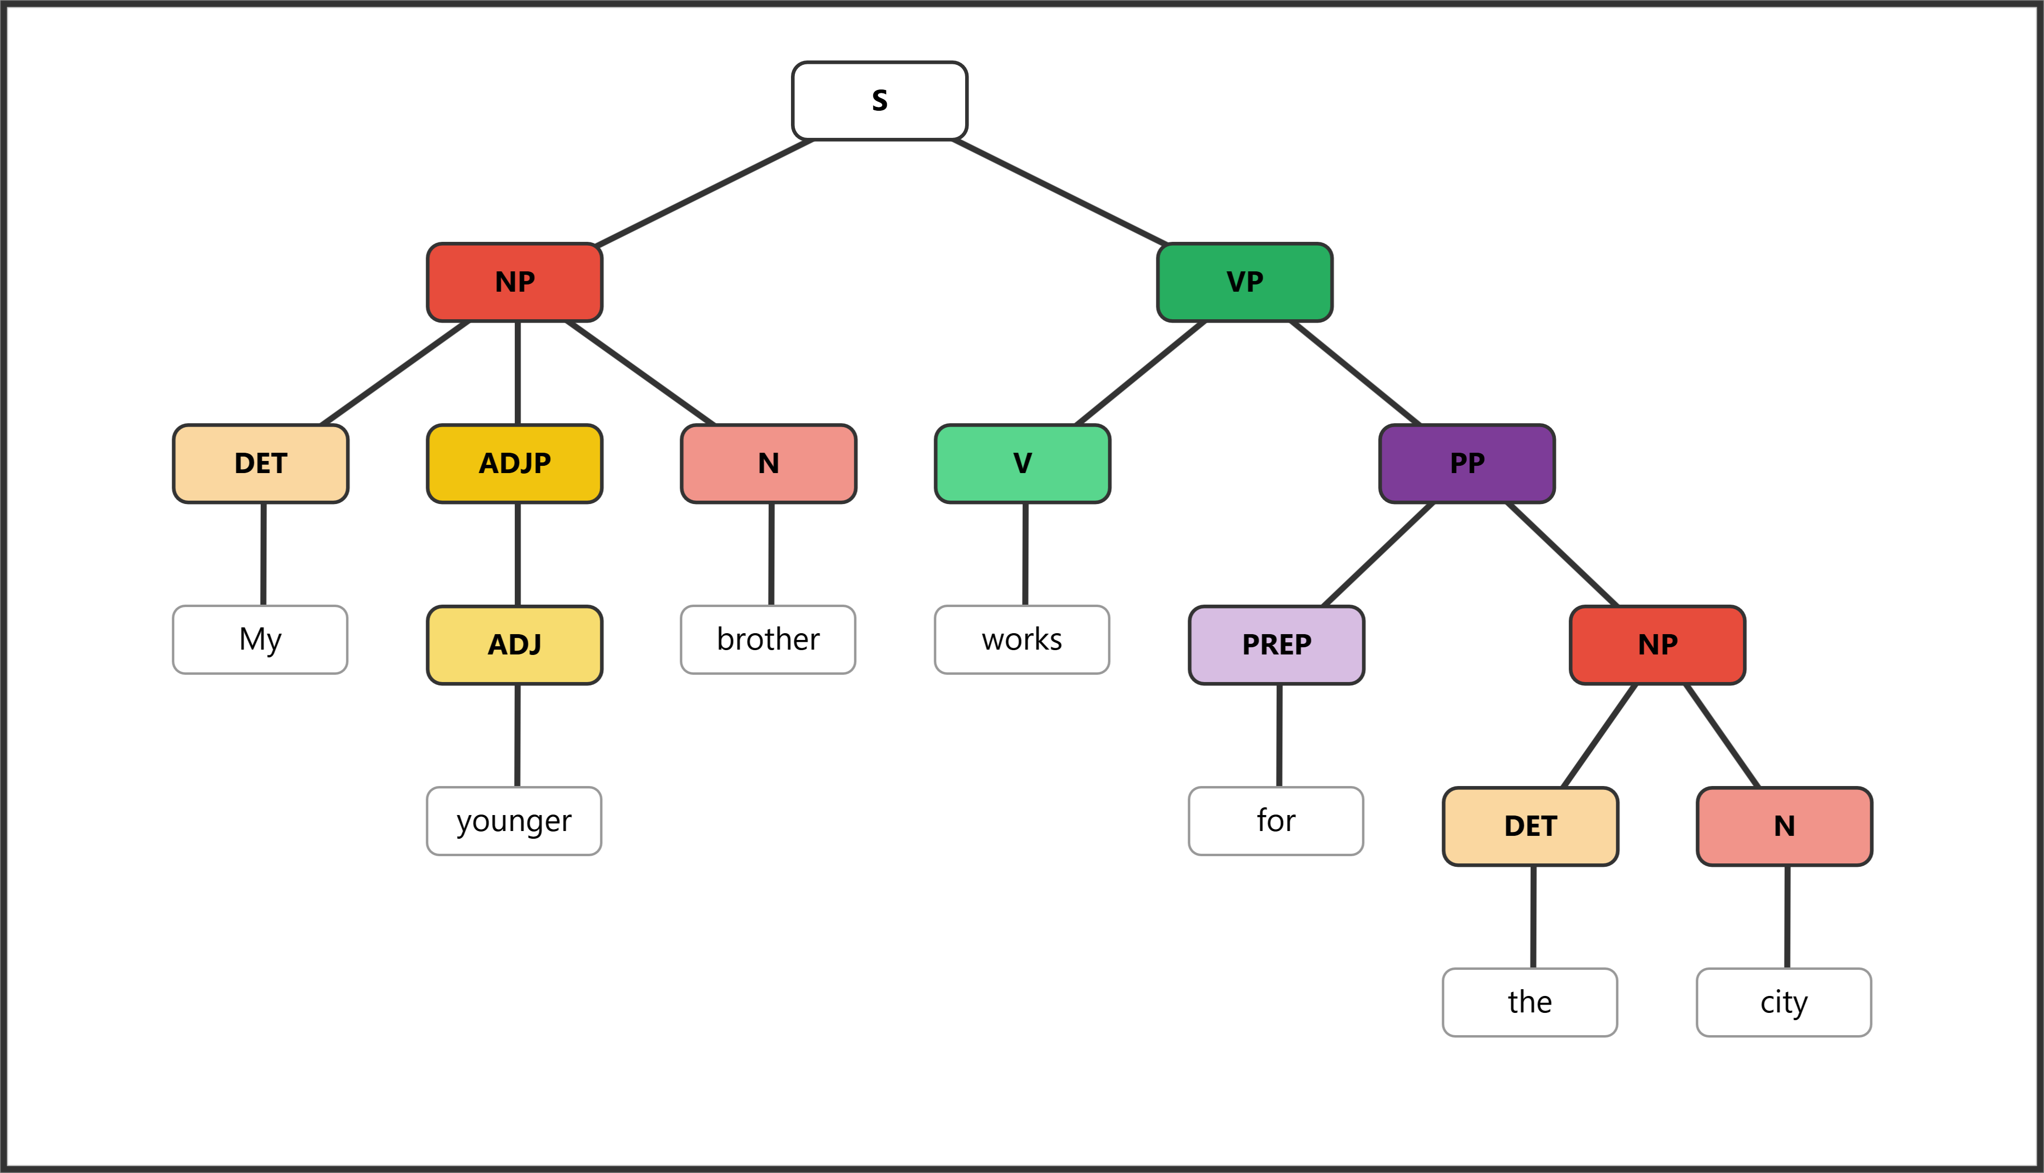
Practice Four: The painfully long discussion continued incessantly until noon.
Phrase | NP | NP | NP | NP | VP | VP | PP | PP
Word | The | painfully | long | discussion | continued | incessantly | until | noon
Part of Speech | Det | Adv | Adj | N | V | Adv | Prep | N

Bracket notation:
[NP The painfully long discussion] [VP continued incessantly [PP until [NP noon]]]
Tree diagram:
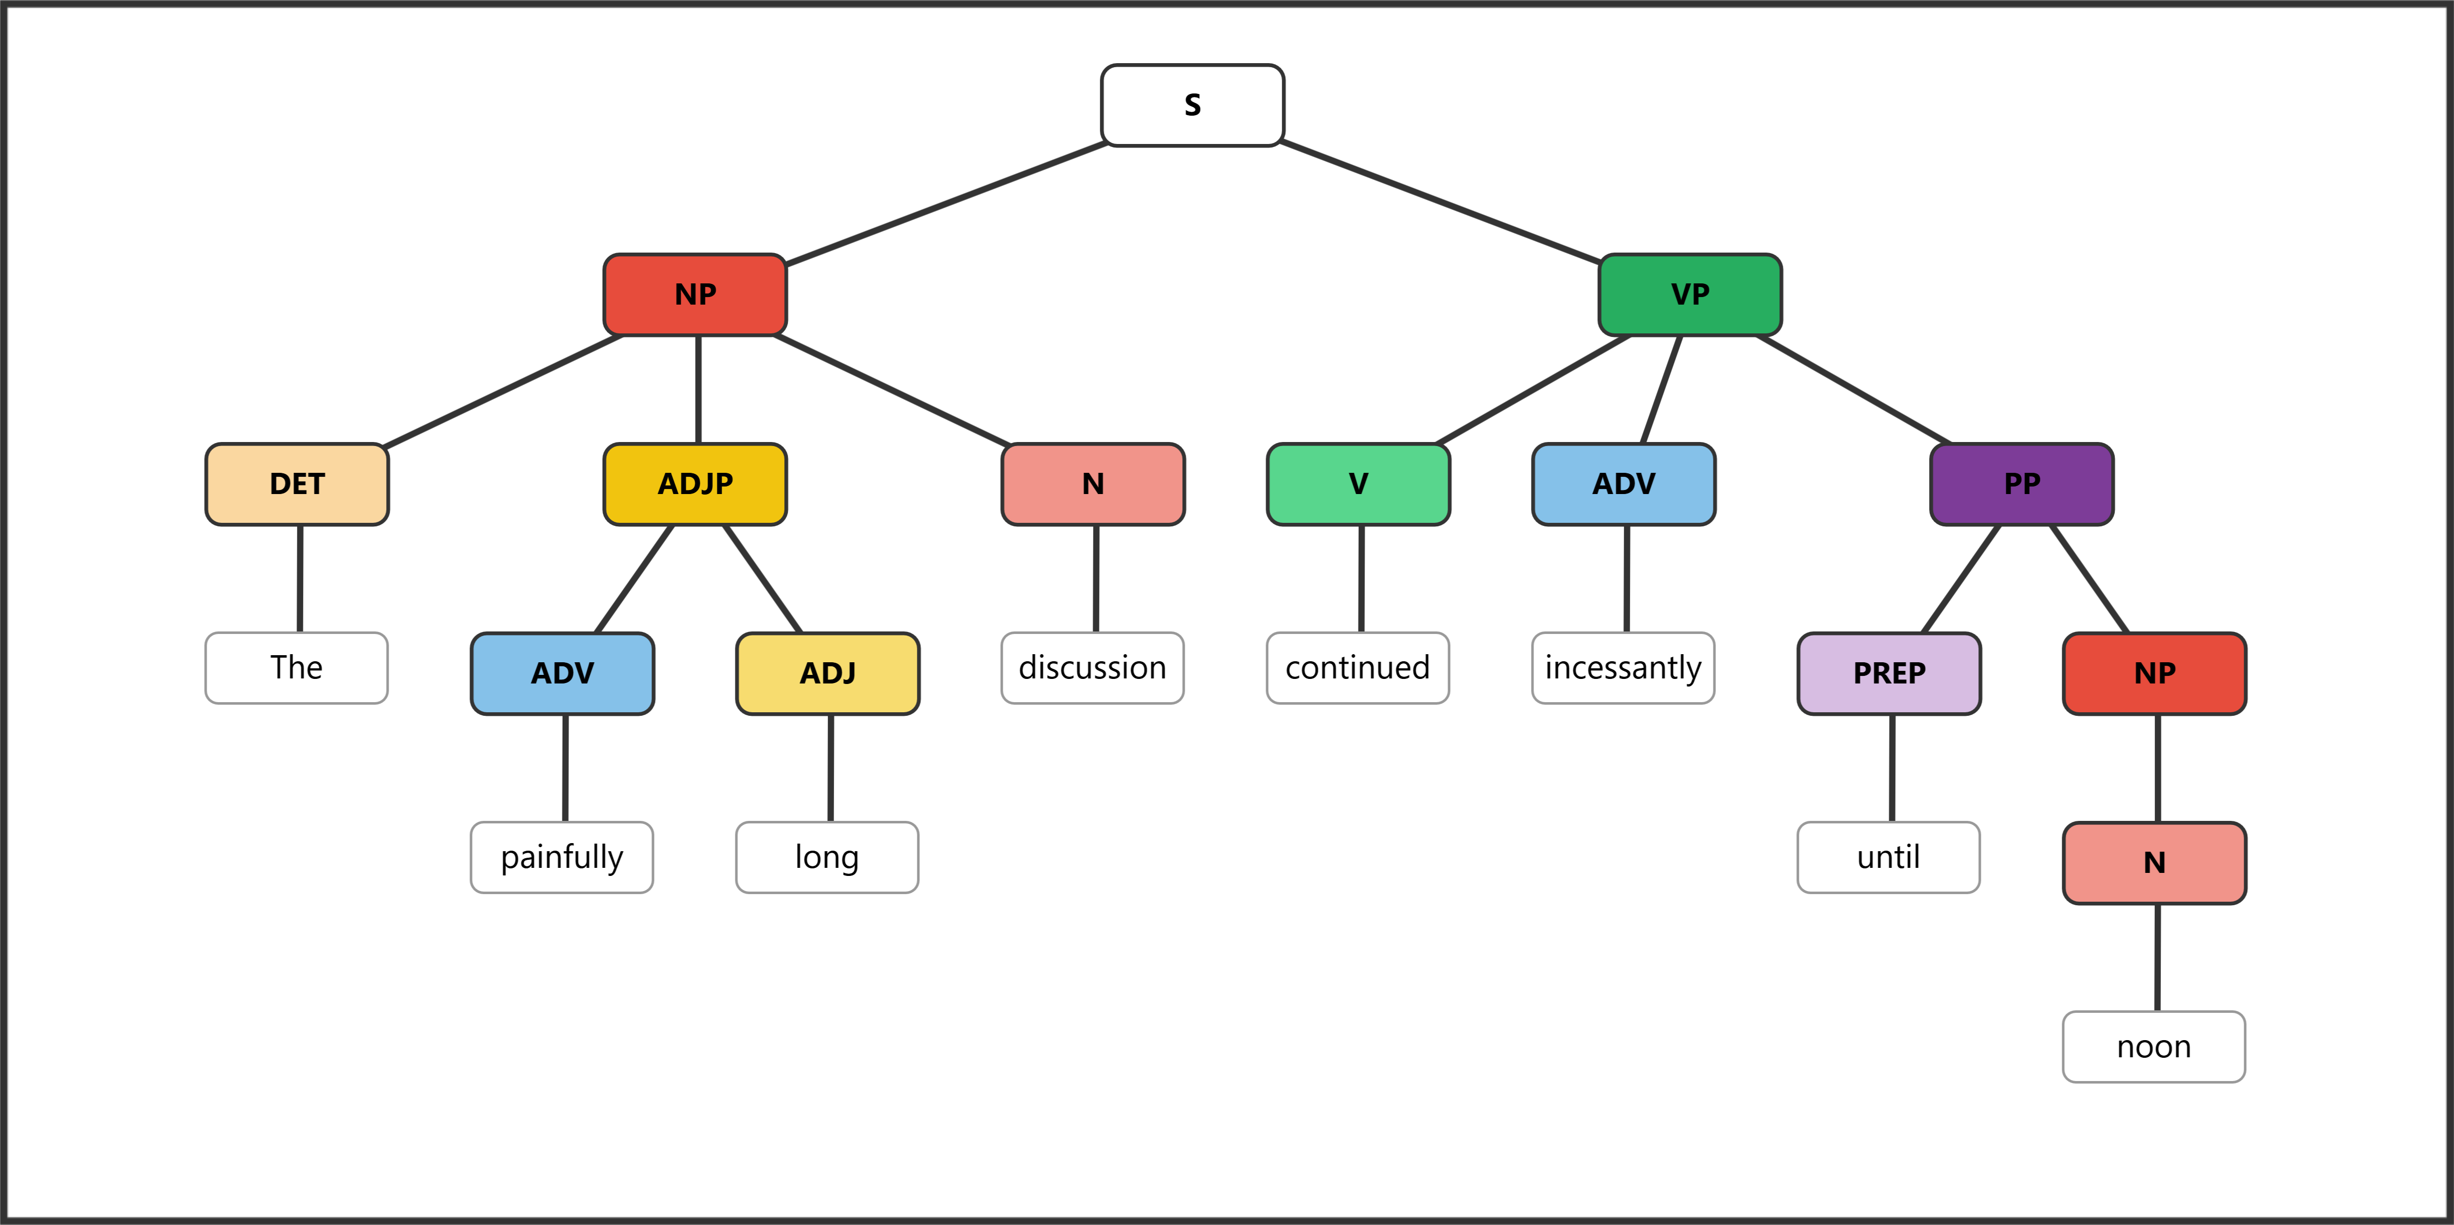
Example Five: All my dearest friends from highschool suddenly left.
Phrase | NP | NP | NP | NP | PP | PP | VP | VP
Word | All | my | dearest | friends | from | highschool | suddenly | left
Part of Speech | Det | Det | Adj | N | Prep | N | Adv | V

Bracket notation:
[NP All my dearest friends [PP from [NP highschool]]] [VP suddenly left]
Tree diagram:
